Template for Preparation of Papers for 3M-NANO Conference Proceedings

Volkmar Eichhorn¹, Daniel Jasper¹, Jia Xu² and Lanjiao Liu²
¹Department of Computing Science, University of Oldenburg, Oldenburg, Germany
²CNM & IJRCNB Centers, Changchun University of Science and Technology, Changchun, China
Corresponding-author@cust.edu.cn

Abstract – These instructions give you the basic guidelines for preparing papers for 3M-NANO conference proceedings. Please use this document as a “template” to prepare your manuscript. For paper submission, follow the instructions on the Conference website at http://www.3M-NANO.org.

Keywords - List keywords here (separated by a comma). No more than three.

I. Introduction
This document is a template for Microsoft Word versions 6.0 or later. You should follow the following guidelines for preparing your papers for 3M-NANO conference proceedings. If you have any problem for using this template, please contact the Secretary of 3M-NANO conference for assistance.

A. Preparing Your Paper
(1) Paper Size: Prepare your paper in full-size format on US letter size paper (8.5 by 11 inches).
(2) Type Sizes and Typefaces: Follow the font type sizes specified in Table 1. The font type sizes are given in points, same as in the MS Word font size points. Times New Roman is the font used.
(3) Paper Margins: Paper margins are set as follows: top = 0.75 inches, bottom = 1 inch, side = 0.625 inches. Each column measures 3.5 inches wide, with a 0.25-inch gap between the two columns.
(4) Paper Styles: Left and right justify the columns. Use high resolution figures (300dpi or above) for the best printing result.

TABLE 1
Type Size for Papers
Type size (pts.) | Appearance
Type size (pts.) | Regular | Bold | Italic
6 | Table superscripts
8 | References, tables, table names*, table captions, figure captions, text subscripts, and superscripts
9 |  | Abstract, Keywords
10 | Authors' affiliations, main text, equations, and section titles* |  | Subheading
11 | Authors' names
20 | Paper title
*Uppercase

B. Preparing Your PDF Paper for 3M-NANO conference
If you do not already have a tool to convert your file to PDF format, you may contact the Secretary of 3M-NANO for assistance.
II. Helpful Hints
A. Figures and Tables
Large figures and tables may span across both columns. Figure captions should be centered below the figures. Table captions should be centered above. Avoid placing figures and tables before their first mention in the text. Use the abbreviation “Fig. *”, even at the beginning of a sentence.
Use words rather than symbols for figure axis labels, as shown in Fig. 1. Put units in parentheses. Do not label axes only with units. In the example, write “Position (pixels)”. Figure labels should be legible, at 8-point type.

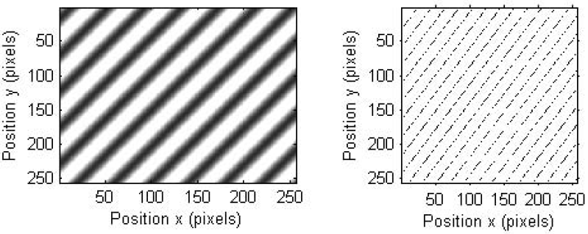
(a) (b)
Fig. 1. (a) Computer generated ideal oblique fringe pattern; (b) edge plot of the ideal oblique fringe pattern.

B. References
Number citations consecutively in square brackets [1]. Punctuation follows the bracket [2]. Refer simply to the reference number as in “Ref. [3]”.
Give all authors’ names; use “et al.” if there are six authors or more [4]. Papers that have not been published, even if they have been submitted for publication, should be cited as “unpublished” [4]. Papers that have been accepted for publication should be cited as “in press” [5]. In a paper title, capitalize the first word and all other words except for conjunctions, prepositions less than seven letters, and prepositional phrases. For papers published in translated journals, first give the English citation, then the original foreign-language one [6]. For a web publication, give the title, web address and date viewed [7].
C. Abbreviations and Acronyms
Define abbreviations and acronyms the first time they are used in the text, even if they have been defined in the abstract. Abbreviations such as SPIE, IEEE, SI, MKS, CGS, ac, dc, and rms do not have to be defined. Do not use abbreviations in the title unless they are unavoidable.
D. Equations
Number equations consecutively with equation numbers in parentheses flush with the right margin, as in (1). To make your equations more compact, you may use the solidus (/) and the exp function, etc. Italicize Roman symbols for quantities and variables, but not Greek symbols. Use an en dash (–) rather than a hyphen for a minus sign. Use parentheses to avoid ambiguities in denominators. Punctuate equations with commas or periods when they are part of a sentence, as in

$r(t)=\frac{\text{cov}[I_{0}(x,y),I_{k}(x±t,y)]}{σ_{I_{0}}σ_{I_{k}}}$, k=0, 1, 2,… (1)

Symbols in your equation should be defined before the equation appears or immediately following. Cite equations using “Eq. (1)”.

E. Other Recommendations
The Roman numerals used to number the section headings are optional. Do not number Acknowledgement and References and begin Subheadings with letters. Use a zero before decimal points: “0.56,” not “.56.” Use “cm³,” not “cc.” Do not add page numbers. If your native language is not English, try to get a native English-speaking colleague to proofread your paper.
III. Units
Use either SI (MKS) or CGS as primary units. (SI units are encouraged.) English units may be used as secondary units (in parentheses). An exception would be the use of English units as identifiers in trade, such as “3.5-inch disk drive.”
Avoid combining SI and CGS units, such as current in amperes and magnetic field in oersteds.
Acknowledgment
Put applicable sponsor acknowledgments here. DO NOT place them on the first page of your paper or as a footnote.
References
- D. S. Snyder and A. M. Hammoud, “Image recovery from data acquired with a charge-coupled-device camera”, J. Opt. Soc. Am. A, vol. 10, no. 5, pp.1014-1023, 1993.
- A. D. Whalen, Detection of Signals in Noise, Academic Press, New York, 1971.
- G. Binning, H. Rohrer, Ch. Gerber, and E. Weibel, “Tunneling through a controllable vacuum gap”, Appl. Phys. Lett., vol. 40, no. 2, pp. 178-180, 1982.
- V. Eichhorn, et al, “Title of paper goes here if known”, unpublished.
- L. Liu, “Title of paper with only the first word capitalized”, J. Name Stand. Abbrev., in press.
- Y. Yorozu, M. Hirano, K. Oka, and Y. Tagawa, “Electron spectroscopy studies on magneto-optical media and plastic substrate interface”, IEEE Translated J. Magn. Japan, vol. 2, pp. 740-741, August 1987 [Digest 9th Annual Conf. Magnetics Japan, p. 301, 1982].
[7] “Welcome to the 3M-NANO International Conference”, http://www.3m-nano.org, viewed on 26 December 2010.

